**“Fast points about 🡪 Fawary , Instapay , Mezza , SEPA , swish , Paypal”**

That definition is important for :

Instant Payment Network 🡪 to allow customers and banks to carry out. instant transfers through electronic payment tools and provide all. segments of society with appropriate banking services.

Mezza 🡪Meeza provides similar electronic payment services as MasterCard and Visa but can only be used locally inside Egypt

🡪Meeza produces bank cards and mobile wallet applications for local transactions within Egypt. Meeza payment cards are accepted in merchandise stores and government organizations across Egypt, in addition to online Egyptian e-commerce websites. Meeza issues both prepaid payment cards and bank account debit cards. The cards are issued by most of the major banks in Egypt like National Bank of Egypt (NBE), Banque Misr, Alex Bank, Banque du Caire, Commercial International Bank (CIB), and other Egyptian banks

instapay

🡪How to receive money on your mobile number?

Your mobile number is associated with the account you have added to InstaPay.

If you have more than one account, you need to select a default account from account management.

This way you will receive the funds when someone sends money to your mobile number

🡪your transfers are free of any applied fees.

Limits are defined as the following:

EGP 70,000 per transaction.

EGP 120,000 daily debit per bank.

EGP 400,000 monthly debit per bank.

Transfer Fees: 0.1% from transaction value, minimum EGP 0.50, maximum EGP 20

Balance Inquiry and Mini-Statement: EGP 0.50 per transaction, customer can enjoy 10 free transaction monthly

Bill Payment: As per each service tariff

Donation: same transfer fees apply

Transfer & Balance Inquiry and Mini-Statement fees to be applied as of 1st of April 2025

Goals of instapay :

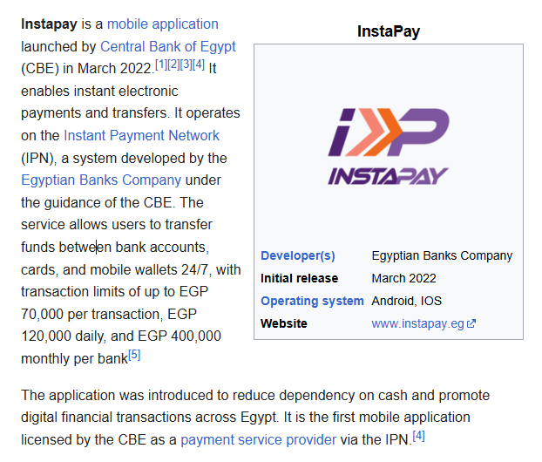

Points for global practices :

SEPA Instant (Europe)

is a payment integration initiative of the European Union for simplification of bank transfers denominated in euros.

As of 2025, there were 40 members in SEPA,[2][3] consisting of the 27 member states of the European Union, the four member states of the European Free Trade Association (Iceland, Liechtenstein, Norway and Switzerland), and the United Kingdom.[4][5][3] Some microstates participate in the technical schemes: Andorra,[6] Monaco, San Marino, and Vatican City.[4] By 2025, Albania, Moldova, Montenegro and North Macedonia were 4 countries negotiating to join the EU already included in SEPA (40 members that contributed)

Goals of the SEPA:

The aim of SEPA as stated in 2008 was to improve the efficiency of cross-border payments and turn the previously fragmented national markets for euro payments into a single domestic one. SEPA would enable customers to make cashless euro payments to any account located anywhere in the area.

using a single bank account and a single set of payment instruments.[9] People who have a bank account in a eurozone country can use it to receive salaries and make payments all over the eurozone, for example when they take a job in a new country. (salaries could be paid through it and also 🡪 use single bank account )

Sweden: Swish

Sweden’s mobile payment app Swish, used by 8 million users (80% population), integrates with cross-border platforms via Tink’s APIs. For example, a Swedish buyer can pay a U.S. merchant via Swish, with funds routed through Tink’s open banking network

The service works through a smartphone application, through which the users' phone numbers are connected to their bank accounts, and which makes it possible to transfer money in real time, a few seconds until confirmation is received by both parties. The user must have a second mobile application called Mobilt BankID Säkerhetsapp, which is an electronic identification issued by several banks in Sweden. This requires that the user has a bank account in a Swedish bank participating in the system, and also a national ID number. Users who have a Swedish bank account but no suitable phone can register for reception only of payments. The phone number can be of another country. The actual transfer is done by the Bankgirot clearing system, which developed instant payments for the Swish system. (could be between different countries point of power)

PayPal :

American multinational financial technology company operating an online payments system in the majority of countries that support online money transfers; it serves as an electronic alternative to traditional paper methods such as checks and money orders. The company operates as a payment processor for online vendors, auction sites and many other commercial users, for which it charges a fee.

Regulations :

Thiel, a founder of PayPal, has said that PayPal is not a bank because it does not engage in fractional-reserve banking. Rather, PayPal's funds that have not been disbursed are kept in commercial interest-bearing checking accounts.

Note::Techincailty comparison 🡪 spea. swish 🡪 uses ipn

* Paypal🡪 ip notification